**WEB TECHNOLOGIES LAB MANUAL-(R22CSE3257)**

Third Year CSE -Semester II

DEPARTMENT OF COMPUTER SCIENCE AND ENGINEERING

**ACADEMIC YEAR 2024-25**



## 3SRI INDU COLLEGE OF ENGINEERING & TECHNOLOGY

**SRI I**

**B. TECH – COMPUTER SCIENCE & ENGINEERING**

**INSTITUTION VISION**

To be a premier Institution in Engineering & Technology and Management with competency, values and social consciousness.

**INSTITUTION MISSION**

**IM1** Provide high quality academic programs, training activities and research facilities.

**IM2** Promote Continuous Industry-Institute Interaction for Employability, Entrepreneurship, Leadership and Research aptitude among stakeholders.

**IM3** Contribute to the Economical and technological development of the region, state and nation.

**DEPARTMENT VISION**

To be a technologically adaptive centre for computing by grooming the students as top notch professionals..

**DEPARTMENT MISSION**

The Department has following Missions:

**DM1** To offer quality education in computing.

**DM2** To provide an environment that enables overall development of all the stakeholders.

**DM3** To impart training on emerging technologies.

**DM4** To encourage participation of stakeholders inResearch and Development.

**PROGRAM EDUCATIONAL OBJECTIVES (PEOs)**

**PEO 1: Higher Studies:** Graduates with an ability to apply knowledge of Basic sciences and programming skills in their career and higher education.

**PEO 2: Domain Knowledge:** Graduates with an ability to adopt new technologies forever changing IT Industry needs through Self-Study, Critical thinking and Problem solving skills**.**

**PEO 3: Professional Career:** Graduates will be ready to work in projects related to complex problems Involving multidisciplinary projects with effective analytical skills.

**PEO 4: Life Long Learning:** Graduates with an ability to communicate well and exhibit social, technical and ethical responsibility in process or product.

**PROGRAM OUTCOMES (POs) & PROGRAM SPECIFIC OUTCOMES (PSOs)**

|  |  |
| --- | --- |
| **PO** | **Description** |
| **PO 1** | **Engineering Knowledge**: Apply knowledge of mathematics, natural science, computing, engineering fundamentals and an engineering specialization as specified in WK1 to WK4 respectively to develop to the solution of complex engineering problems. |
| **PO 2** | **Problem Analysis:** Identify, formulate, review research literature and analyze complex engineering problems reaching substantiated conclusions with consideration for sustainable development. (WK1 to WK4) |
| **PO 3** | **Design/Development of Solutions:** Design creative solutions for complex engineering problems and design/develop systems/components/processes to meet identified needs with consideration for the public health and safety, whole-life cost, net zero carbon, culture, society and environment as required. (WK5) |
| **PO 4** | **Conduct Investigations of Complex Problems:** Conduct investigations of complex engineering problems using research-based knowledge including design of experiments, modelling, analysis & interpretation of data to provide valid conclusions. (WK8). |
| **PO 5** | **Engineering Tool Usage:** Create, select and apply appropriate techniques, resources and modern engineering & IT tools, including prediction and modelling recognizing their limitations to solve complex engineering problems. (WK2 and WK6) |
| **PO 6** | **The Engineer and The World:** Analyze and evaluate societal and environmental aspects while solving complex engineering problems for its impact on sustainability with reference to economy, health, safety, legal framework, culture and environment. (WK1, WK5, and WK7). |
| **PO 7** | **Ethics**: Apply ethical principles and commit to professional ethics, human values, diversity and inclusion; adhere to national & international laws. (WK9) |
| **PO 8** | **Individual and Collaborative Team work**: Function effectively as an individual, and as a member or leader in diverse/multi-disciplinary teams. |
| **PO 9** | **Communication:** Communicate effectively and inclusively within the engineering community and society at large, such as being able to comprehend and write effective reports and design documentation, make effective presentations considering cultural, language, and learning differences.. |
| **PO 10** | **Project Management and Finance**: Apply knowledge and understanding of engineering management principles and economic decision-making and apply these to one’s own work, as a member and leader in a team, and to manage projects and in multidisciplinary environments**.** |
| **PO 11** | **Life-Long Learning**: Recognize the need for, and have the preparation and ability for  i) independent and life-long learning  ii) adaptability to new and emerging technologies and  iii) critical thinking in the broadest context of technological change. (WK8) |
| **Program Specific Outcomes** | |
| **PSO 1** | To develop software projects using standard practices and suitable programming environment. |
| **PSO 2** | To identify, formulate and solve the real-life problems faced in the society, industry and other areas by applying the skills of the programming languages, networks and databases learned. |
| **PSO 3** | To apply computer science knowledge in exploring and adopting latest technologies in various inter-disciplinary  research activities. |

# DEPARTMENT OF COMPUTER SCIENCE AND ENGINEERING

**COURSE OUTCOMES (CO’S)**

**COURSE NAME: WEB TECHNOLOGIES LAB**

|  |  |  |  |
| --- | --- | --- | --- |
| Semester No: | III/II | | |
| Course Title: | Web Technologies Lab | Course Code | R22CSE3257 |
| Course Outcome No. | Course Outcome Statements | | |
| C32L8.1 | Use xamp for web applications using PHP. | | |
| C32L8.2 | Write simple applications with technologies like XML, HTML. | | |
| C32L8.3 | Use Tomcat Server for Servlets and JSP technologies. | | |
| C32L8.4 | Write applications with AJAX, JavaScript. | | |

**COURSE ARTICULATION MATRIX**

|  |  |  |  |  |  |  |  |  |  |  |  |  |  |  |
| --- | --- | --- | --- | --- | --- | --- | --- | --- | --- | --- | --- | --- | --- | --- |
| Course Outcome (COs)Code & Statement | Program Outcomes (POs) | | | | | | | | | | | Program Specific Outcomes (PSOs) | | |
| PO1 | PO2 | PO3 | PO4 | PO5 | PO6 | PO7 | PO8 | PO9 | PO10 | PO11 | PSO1 | PSO2 | PSO3 |
| CO 1 | 1 | 2 | 3 | 3 | 3 | 1 | - | - | - | - | 3 | 3 | 2 | 3 |
| CO 2 | 1 | 3 | 3 | 3 | 3 | - | - | - | - | - | 2 | 3 | 3 | 3 |
| CO 3 | 1 | 3 | 3 | 3 | 3 | - | - | - | 1 | - | 2 | 3 | 3 | 3 |
| CO 4 | 1 | 2 | 3 | 2 | 3 | 1 | - | - | - | - | 2 | 3 | 2 | 3 |
|  | 2 | 2 | 2.75 | 1.75 |  |  |  |  | 2 |  |  | 2 | 2 |  |

**SRI INDU COLLEGE OF ENGINEERING & TECHNOLOGY**

**(An Autonomous Institution under UGC, New Delhi)**

**B.Tech. - III Year – II Semester**

**L T P C**

**0 0 2**

**1**

**Professional Elective – III LAB**

**(R22CSE3257) WEB TECHNOLOGIES LAB**

**WEB TECHNOLOGIES LAB**

1.Install the following on the local machine Apache Web Server (if not installed)

• Tomcat Application Server locally

• Install MySQL (if not installed)

• Install PHP and configure it to work with Apache web server and

•MySQL (if not already configured)

2.Write an HTML page including any required Javascript that takes a number from one text field in

the range of 0 to 999 and shows it in another text field in words. If the number is out of range, it

should show ―out of range‖ and if it is not a number, it should show ―not a number‖ message in the

result box.

3.Write an HTML page that has one input, which can take multi-line text and a submit button. Once

the user clicks the submit button, it should show the number of characters, words and lines in the

text entered using an alert message. Words are separated with white space and lines are separated

with new line character.

4.Write an HTML page that contains a selection box with a list of 5 countries. When the user selects

a country, its capital should be printed next to the list. Add CSS to customize the properties of the

font of the capital (color, bold and font size).

5.Create an XML document that contains 10 users information. Write a Java program, which takes

User Id as input and returns the user details by taking the user information from the XML document

using

(a) DOM Parser and

(b) SAX parser

6. Implement the following web applications using

(a) PHP,

(b) Servlets and

(c) JSP:

i. A user validation web application, where the user submits the login name and password to

the server. The name and password are checked against the data already available in

Database and if the data matches, a successful login page is returned. Otherwise a failure

message is shown to the user.

ii. Modify the above program to use an xml file instead of database.

iii. Modify the above program to use AJAX to show the result on the same page below the

submit button.

iv. A simple calculator web application that takes two numbers and an operator (+, -, /, * and

%) from an HTML page and returns the result page with the operation performed on the

operands.

v. Modify the above program such that it stores each query in a database and checks the

database first for the result. If the query is already available in the DB, it returns the valuethat was previously computed (from DB) or it computes the result and returns it after

storing the new query and result in DB.

vi. A web application takes a name as input and on submit it shows a hello page where is

taken from the request. It shows the start time at the right top corner of the page and

provides a logout button. On clicking this button, it should show a logout page with Thank

You message with the duration of usage (hint: Use session to store name and time).

vii. A web application that takes name and age from an HTML page. If the age is less than 18,

it should send a page with ―Hello , you are not authorized to visit this site‖ message, where

should be replaced with the entered name. Otherwise it should send ―Welcome to this site‖

message.

viii. A web application for implementation:

The user is first served a login page which takes user‘s name and password. After

submitting the details the server checks these values against the data from a database and

takes the following decisions.

If name and password matches, serves a welcome page with user‘s full name. If name

matches and password doesn‘t match, then serves ―password mismatch‖ page If name is not

found in the database, serves a registration page, where user‘s full name is asked and on

submitting the full name, it stores, the login name, password and full name in the database

(hint: use session for storing the submitted login name and password)

ix. A web application that lists all cookies stored in the browser on clicking ―List Cookies‖

button.Add cookies if necessary

***Outcomes:***

xUse LAMP Stack for web

applications Use Tomcat Server

for Servlets and JSPs

Write simple applications with Technologies like HTML,

Javascript, AJAX, PHP, Servlets and JSPs Connect to

Database and get results Parse XML files using Java (DOM

and SAX parsers)

**SRI INDU COLLEGE OF ENGINEERING & TECHNOLOGY**

# **B. TECH –COMPUTER SCIENCE AND ENGINEERING**Description: 3

# **List of Experiments**

|  |  |  |  |
| --- | --- | --- | --- |
| **S.No** | **Name Of The Experiment** | **No. of**  **Class required** | **COS** |
| 1 | **Week 1-:** Install the following on the local machine Apache Web  Server (if not installed) • Tomcat Application Server locally • Install MySQL (if not installed) • Install PHP and configure it to work with Apache web server and • MySQL (if not already configured) | **3** | **CO1** |
| 2 | **Week 2-:**Write an HTML page including any required Javascript that takes a number from one text field in the range of 0 to 999 and shows it in another text field in words. If the number is out of range, it should show ―out of range‖ and if it is not a number, it should show ―not a number‖ message in the result box | **3** | **CO1** |
| 3 | **Week 3-:**Write an HTML page that has one input, which can take multi-line text and a submit button. Once the user clicks the submit button, it should show the number of characters, words and lines in the text entered using an alert message. Words are separated with white space and lines are separated with new line character. | **3** | **CO2** |
| 4 | **Week 4-:**Write an HTML page that contains a selection box with a list of 5 countries. When the user selects a country, its capital should be printed next to the list. Add CSS to customize the properties of the font of the capital (color, bold and font size). | **3** | **CO1** |
| 5 | **Week 5-:**Create an XML document that contains 10 users information. Write a Java program, which takes User Id as input and returns the user details by taking the user information from the XML document using (a) DOM Parser and (b) SAX parser | **3** | **CO2** |
| 6 | **Week 6-:**Implement the following web applications using (a) PHP, (b) Servlets and (c) JSP: | **21** | **CO3,CO4** |
| **i.** A user validation web application, where the user submits the login name and password to the server. The name and password are checked against the data already available in Database and if the data matches, a successful login page is returned. Otherwise a failure message is shown to the user. |
| **ii.** Modify the above program to use an xml file instead of database. |
| **iii.** Modify the above program to use AJAX to show the result on the same page below the submit button. |
| **iv.** A simple calculator web application that takes two numbers and an operator (+, -, /, * and %) from an HTML page and returns the result page with the operation performed on the operands. |
| **v.** Modify the above program such that it stores each query in a database and checks the database first for the result. If the query is already available in the DB, it returns the value that was previously computed (from DB) or it computes the result and returns it after storing the new query and result in DB. |
| **vi.** A web application takes a name as input and on submit it shows a hello page where is taken from the request. It shows the start time at the right top corner of the page and provides a logout button. On clicking this button, it should show a logout page with Thank You message with the duration of usage (hint: Use session to store name and time). |
| **vii.** A web application that takes name and age from an HTML page. If the age is less than 18, it should send a page with ―Hello , you are not authorized to visit this site‖ message, where should be replaced with the entered name. Otherwise it should send ―Welcome to this site‖ message |
| **viii.** A web application for implementation: The user is first served a login page which takes user‘s name and password. After submitting the details the server checks these values against the data from a database and takes the following decisions. If name and password matches, serves a welcome page with user‘s full name. If name matches and password doesn‘t match, then serves ―password mismatch‖ page If name is not found in the database, serves a registration page, where user‘s full name is asked and on submitting the full name, it stores, the login name, password and full name in the database (hint: use session for storing the submitted login name and password) |
| **ix.** A web application that lists all cookies stored in the browser on clicking ―List Cookies button.Add cookies if necessary |

**LAB INCHARGE HOD**

# EXPERIMENT-1

**PROBLEM STATEMENT:** Install the following on local machine

Apache Web Server Install MySQL

Install PHP and configure it to work with apache web server and MySQL Tomcat Application Server Locally

**AIM:** Installing and configuring Apache web server, MySQL with PHP in Linux Environment

# PROCEDURE:

## Step1: Install Apache Web server

$ sudo apt-get update

$ sudo apt-get install apache2

To verify the installation use the following statement [http://localhost](http://localhost/) or [http://server-public-ip-address](http://server-public-ip-address/)

# OUTPUT:

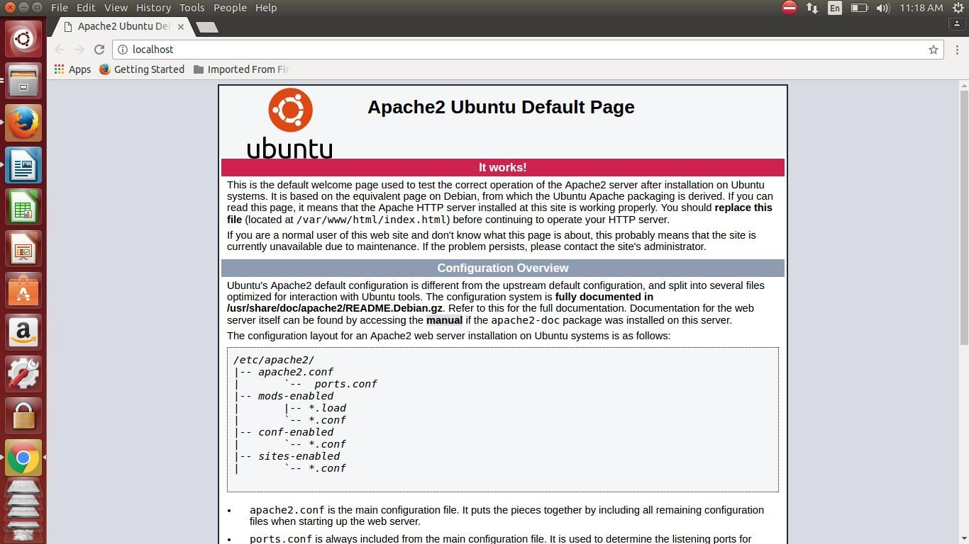

## Step2: Installation of mysql server

$ sudo apt-get install mysql-server php5-mysql

During the installation, your server will ask you to select and confirm a password for the MySQL "root" user. This is an administrative account in MySQL that has increased privileges. Think of it as being similar to the root account for the server itself (the one you are configuring now is a MySQL-specific account however).

When the installation is complete, we need to run some additional commands to get our MySQL environment set up securely.

First, we need to tell MySQL to create its database directory structure where it will store its information. You can do this by typing: **$ sudo mysql_install_db**

Run a security script that will remove some dangerous defaults and lock down access to our database system a little bit.

## $ sudo mysql_secure_installation

Enter the password you set for the MySQL root account. Next, it will ask you if you want to change that password. If you are happy with your current password, type "n" for "no" at the prompt.

For the rest of the questions, you should simply hit the "ENTER" key through each prompt to accept the default values.

## Step3: Installation of PHP

**$ sudo apt-get install php5 libapache2-mod-php5 php5-mcrypt Testing the PHP:**

if a user requests a directory from the server, Apache will first look for a file called

index.html. We want to tell our web server to prefer PHP files, so we'll make Apache look for an index.php file first. To do this, type this command to open the dir.conf file in a text editor with root privileges:

## $ sudo nano /etc/apache2/mods-enabled/dir.conf

<IfModule mod_dir.c>

DirectoryIndex index.html index.cgi index.pl index.php index.xhtml index.htm

</IfModule>

The above code need to be replace by the following code:

<IfModule mod_dir.c>

DirectoryIndex index.php index.html index.cgi index.pl index.xhtml index.htm

</IfModule>

Save and close the file by pressing "CTRL-X". Restart the apache server

$ sudo service apache2 restart

**Test PHP Processing on your Web Server :**( Create a file info.php)

In order for Apache to find the file and serve it correctly, it must be saved to a very specific directory, which is called the "web root". In Ubuntu 14.04, this directory is located at /var/www/html/. We can create the file at that location by typing:

$ sudo nano /var/www/html/info.php

This will open a blank file. put the following text, which is valid PHP code, inside the file:

<?php phpinfo(); ?> save and close the file.

The address you want to visit will be: http://your_server_IP_address/info.php

EX: <http://localhost/info.php>

# OUTPUT:

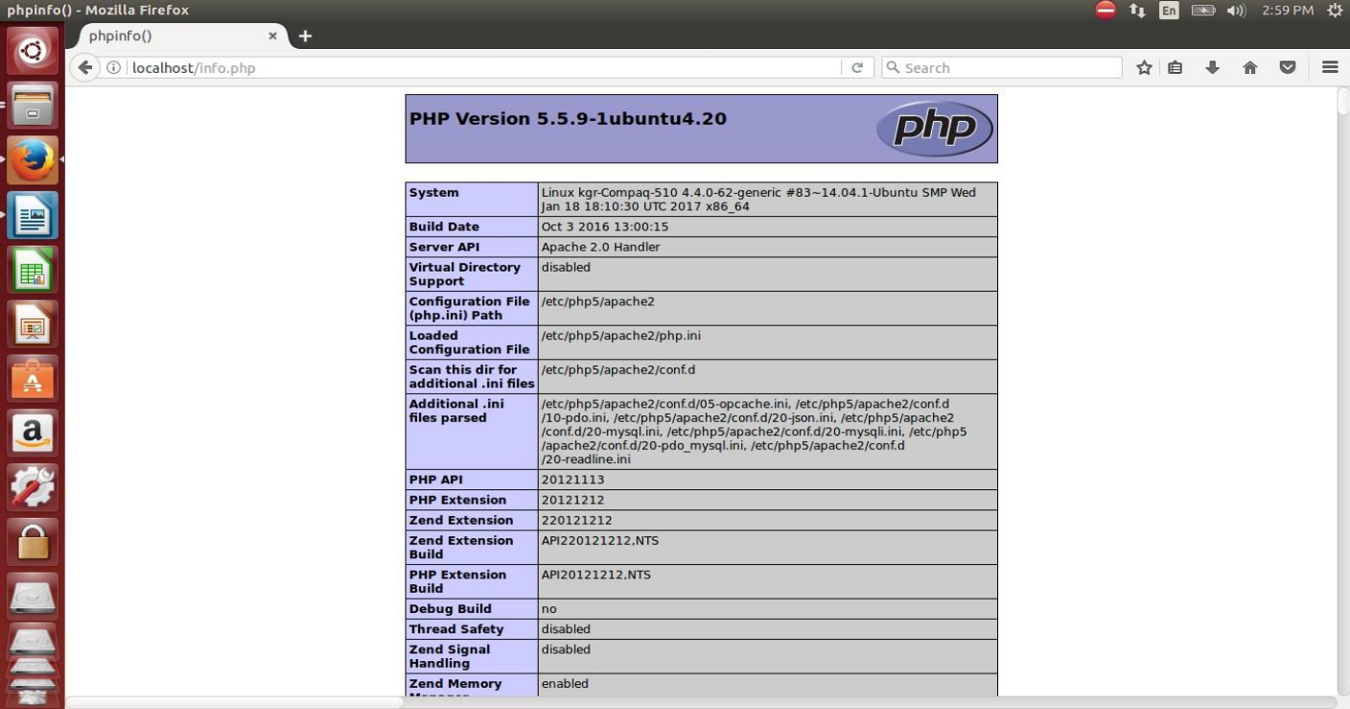

## Step 4: Installation & Configuration of Tomcat8 Application Server in Ubuntu 14.04

1. **Download Apache Tomcat from the follwoing link:**

<http://tomcat.apache.org/download-80.cgi>

Select the version 8.0.42 and click on Zip under Core.

## Extact the downloaed apache tomcat8 into documents folder

1. **Open Eclipse Environment**
   * Click on Servers Tab
   * Click on No servers are available. Click this link to create a new server...
   * Click Tomcat v8.0 Server and Next select apache installation directory and click on Finish.

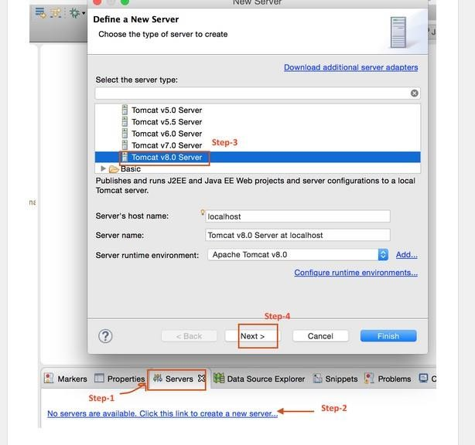

You should see Tomcat v8.0 Server at localhost [Stopped, Republish] under Servers tab. Double click on it verify HTTP ports information. By default HTTP port is 8080.

Right click on the server in "Servers" view, select "Properties".

* + In the "General" panel, click on the "Switch Location" button.
  + The "Location: [workspace metadata]" should replace by something else.
  + Open the Overview screen for the server by double clicking it.
  + In the Server locations tab , select "Use Tomcat location".
  + Save the configurations and restart the Server.

Type the link http://localhost:8080 in browser o access the tomcat home page and manager.

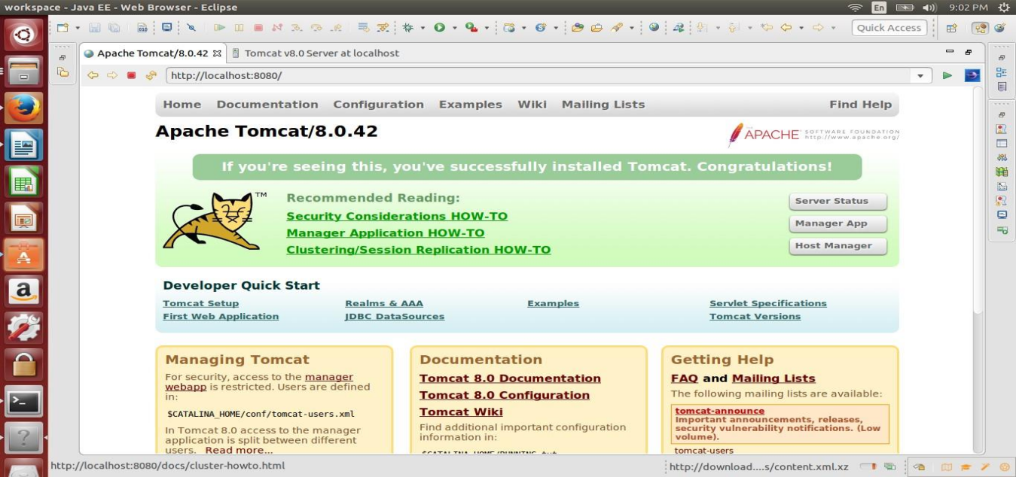

**Click on webapps manager in Managing Tomcat option and enter username: admin and paswword: password then it will show the list applications deployed on to webapps in tomcat.**

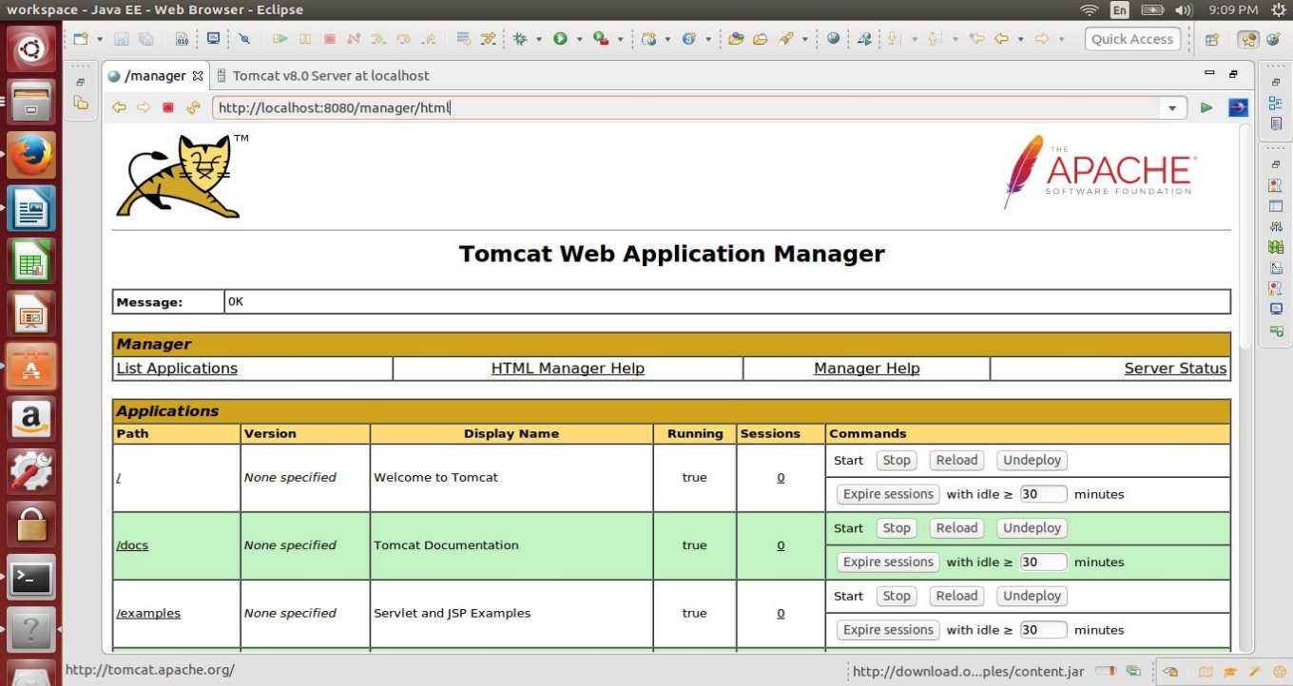

# EXPERIMENT-2

**PROBLEM STATEMENT:**

Write an HTML page including javascript that takes a given set of integer numbers and shows them after sorting in descending order.

**AIM:** Sorting Array elements in descending order.

# PROGRAM:

<!DOCTYPE html>

<html>

<body>

<h2>JavaScript Array Sort</h2>

<p>Click the button to sort the array in descending order.</p>

<button onclick="myFunction()">Try it</button>

<p id="demo"></p>

<script> var points = [40, 100, 1, 5, 25, 10]; document.getElementById("demo").innerHTML = points;

function myFunction() { points.sort(function(a, b){return b - a}); document.getElementById("demo").innerHTML

= points;

}

</script>

</body>

</html>

**OUTPUT:**

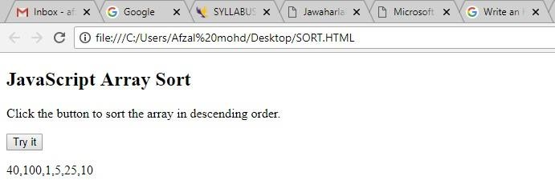

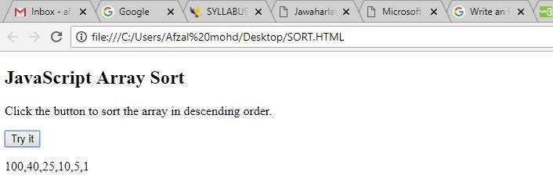

**EXPERIMENT - 3**

**PROBLEM STATEMENT:**

Write html page to take a number from text field in the range 0 to 999 and display in other text field in words. If number is out of range display alert with “out of range” & display “Not a number” if it is not a number.

**AIM:** Read the number from a text field and display in words format in another text field.

# PROGRAM:

<html>

<script type="text/javascript"> var nume=document.getElementById('num').value; function isNumeric(){ var elem=document.niw.num.value; if(elem!="") { var numericExpression = /^[0-9]+$/;

if(elem<0||elem>999)

{ alert("Please Enter Number from 0 to 999"); document.niw.num.value=""; return false;

}

else if(elem.match(numericExpression)){ return true;

}else{ alert("Please Enter Only Number "); document.niw.num.value="";

return false;

} } }

function numinwrd()

{ var numbr=document.getElementById('num').value; var str=new String(numbr)

var splt=str.split(""); var rev=splt.reverse(); var once=['Zero', ' One', 'Two', 'Three', 'Four','Five', 'Six',

'Seven', 'Eight', 'Nine']; var twos=['Ten', ' Eleven', ' Twelve', ' Thirteen', ' Fourteen', ' Fifteen', ' Sixteen', ' Seventeen', ' Eighteen',

' Nineteen']; var tens=[ '', 'Ten', ' Twenty', ' Thirty', ' Forty', ' Fifty', ' Sixty', ' Seventy', ' Eighty', ' Ninety' ]; numlen=rev.length; var word=new Array(); var j=0; for(i=0;i<numlen;i++) { switch(i) { case 0:

if((rev[i]==0) || (rev[i+1]==1))

{word[j]='';} else {word[j]=once[rev[i]];} word[j]=word[j] ; break; case 1:

abovetens(); break; case 2:

if(rev[i]==0) {word[j]='';} else

if((rev[i-1]==0) || (rev[i-2]==0) )

{word[j]=once[rev[i]]+"Hundred ";}

else

{word[j]=once[rev[i]]+"Hundred and";} break; case 3:

if(rev[i]==0 || rev[i+1]==1) {word[j]='';} else{word[j]=once[rev[i]];} default:break;}j++;

} function abovetens()

{if(rev[i]==0){word[j]='';} else if(rev[i]==1){word[j]=twos[rev[i-1]];}else{word[j]=tens[rev[i]];}

} word.reverse(); var finalw=''; for(i=0;i<numlen;i++)

{finalw= finalw+word[i];

}

document.niw.word.value=finalw;

}

</script>

<form name="niw">

<table align=center width=100% style="font-size: 12px; display: block;">

<tr><td>

<table width=100% style="font-family: Monaco, Verdana, Sans-serif; font-size: 12px; display: block; margin-top: 14px;padding: 12px 20px 12px 20px;">

<tr> <td>Number:</td>

<td><input type="text" name="num" id="num" maxlength=9 onKeyup="isNumeric()"></td>

<td><input type="button" name="sr1" value="Click Here" onClick="numinwrd()"></td>

<td>Number in Words:</td>

<td><input type="text" name="word" id="word" size=30></td></tr>

</table>

</td></tr>

</table>

</form>

</html>

# OUTPUT:

**If the value is in range and enters value is a number**

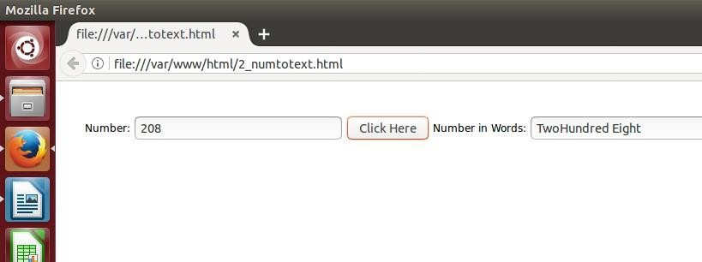

**If the value is out of range**

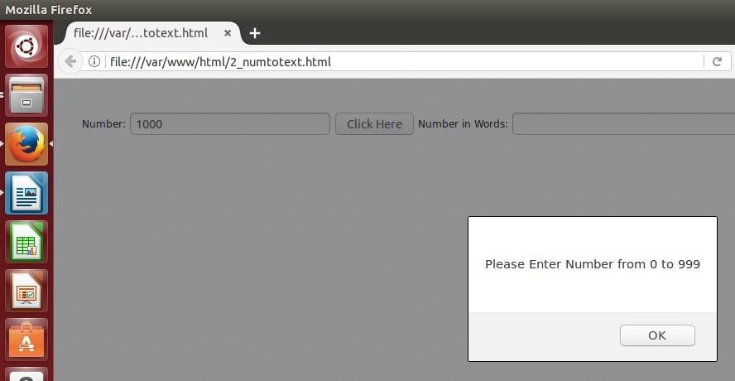

**If the given value is not a number**

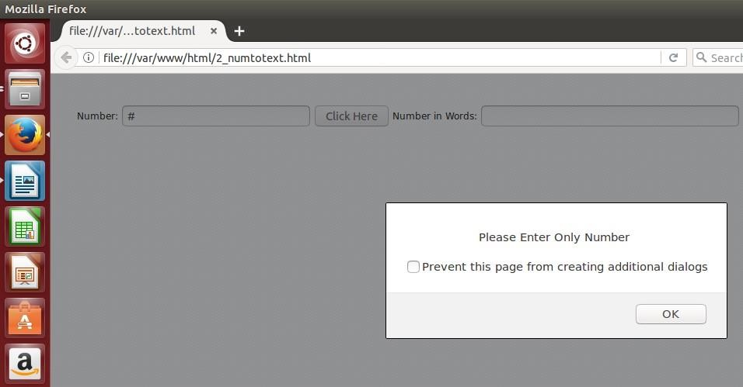

# EXPERIMENT-4

Write html page which can take multi-line text and display the no. Of characters, words and lines in the text entered using alert message.

# AIM:

Html page which can take multi-line text and display the no. Of characters, words and lines in the text entered using alert message.

# PROGRAM:

<html>

<script type="text/javascript"> function countWCL() { var textarea=document.getElementById("tarea"); var text = textarea.value; value = "Words: " + (text.split(/\b\S+\b/).length - 1) + " Characters: " + text.replace(/\s/g, "").length + "

/ " + text.replace(/\n/g, "").length + "lines:" + text.split("\n").length; alert(value);

}

</script>

<form name="cwl">

Enter Multi Line Text <br>

<textarea name="string" id="tarea" rows=4 cols=30></textarea>

<input type="button" name="sub" value="count" onClick="countWCL()"> </form>

</html>

# OUTPUT:

**EXPERIMENT-5**

Choose a country name option from selection box and display it in capital letters by applying CSS style such as color, bold and font size.

# AIM:

Displaying the selected country name in web page by assigning css styles such as color,bold and font size.

# PROGRAM:

<html>

<title> country name as capital

</title>

<head> <style> div.capstr{ color: red; font-style: bold; font-size:12pt; text- transform: uppercase;

}

</style>

</head>

<body>

<select id="country" onchange="getcap();">

<option value="india">india </option>

<option value="sri lanka">sri lanka </option>

<option value="china">china </option>

<option value="london">london </option>

<option value="uk">uk </option>

</select>

<div class="capstr" id="capcountry"> </div>

<script type="text/javascript"> function getcap()

{ document.getElementById("capcountry").innerHTML = document.getElementById("country").value; }

</script>

</div >

</body>

</html>

# OUTPUT:

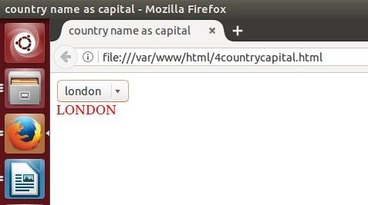

**EXPERIMENT-6**

Create an xml document that contains 10 users information. Write a java program, which takes user id and returns the user details by taking from xml document using DOM Parser.

**AIM:** generating an xml file containing 10 users information. display the user details by taking user information from xml file using java progrgam.

# PROGRAM:

## users.xml

**<?xml version=*"1.0"* encoding=*"UTF-8"*?>**

<employees>

<employee id=*"501"*>

<firstName>Sunil</firstName>

<lastName>Yadav</lastName>

<location>Hyd</location>

</employee>

<employee id=*"502"*>

<firstName>Trilok</firstName>

<lastName>Reddy</lastName>

<location>Chevella</location>

</employee>

<employee id=*"503"*>

<firstName>Mallikarjun</firstName>

<lastName>Tiger</lastName>

<location>Forest</location>

</employee>

<employee id=*"504"*>

<firstName>Neelima</firstName>

<lastName>Lakshmi</lastName>

<location>MP</location>

</employee>

<employee id=*"505"*>

<firstName>Abhi</firstName>

<lastName>Shambu</lastName>

<location>LD</location>

</employee>

<employee id=*"506"*>

<firstName>Nikitha</firstName>

<lastName>Reddy</lastName>

<location>UP</location>

</employee>

<employee id=*"507"*>

<firstName>Ashwini</firstName>

<lastName>Reddy</lastName>

<location>ADB</location>

</employee>

<employee id=*"508"*>

<firstName>Vinod</firstName>

<lastName>Kumar</lastName>

<location>MGD</location>

</employee>

<employee id=*"509"*>

<firstName>Raghu</firstName>

<lastName>Reddy</lastName>

<location>MBD</location>

</employee>

<employee id=*"510"*>

<firstName>Uma Shankar</firstName>

<lastName>Kommana</lastName>

<location>DSNR</location>

</employee>

</employees>

## 6(a) EMPLOYEEPARSING.JAVA (USING DOM PARSER)

import org.w3c.dom.*; import javax.xml.parsers.*; import java.io.*;

public class EmployeeParsing {

public static void main(String[] args)throws Exception {

//Get Document Builder

DocumentBuilderFactory factory = DocumentBuilderFactory.newInstance(); DocumentBuilder builder = factory.newDocumentBuilder();

//Build Document

Document document = builder.parse(new File("User.xml"));

//Normalize the XML Structure; It's just too important !!

//document.getDocumentElement().normalize();

// TODO Auto-generated method stub

//Here comes the root node

Element root = document.getDocumentElement();

BufferedReader br=new BufferedReader(new InputStreamReader(System.in)); System.out.println("Enter User Id");

String id=br.readLine();

//Get all employees

NodeList nList = document.getElementsByTagName("employee"); System.out.println(root.getNodeName()); System.out.println("============================");

for (int temp = 0; temp < nList.getLength(); temp++)

{

Node node = nList.item(temp);

System.out.println(""); //Just a separator if (node.getNodeType() == Node.ELEMENT_NODE)

{

//Print employee's details of given id

Element eElement = (Element) node; if(eElement.getAttribute("id").equals(id))

{

System.out.println("Employee id : " + eElement.getAttribute("id")); System.out.println("First Name : " +

eElement.getElementsByTagName("firstName").item(0).getTextContent()); System.out.println("Last Name : " +

eElement.getElementsByTagName("lastName").item(0).getTextContent()); System.out.println("Location : " +

eElement.getElementsByTagName("location").item(0).getTextContent());

}

}

}

}

**}**

# OUTPUT:

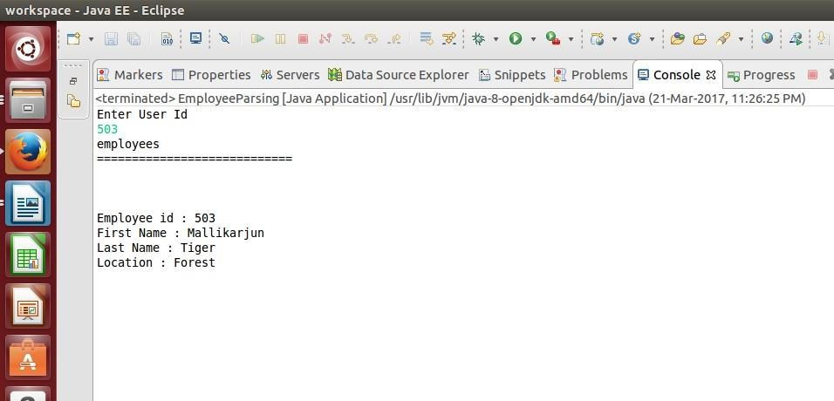

## 6(b) SAX PARSER

**package xmltojavasax; public class** Employee {

**private** String id; **private** String firstname; **private** String lastname;

**private** String location;

**public** String getId() {

**return** id;

}

**public void** setId(String id) {

**this**.id = id;

}

**public** String getFirstName() {

**return** firstname;

}

**public void** setFirstName(String firstname) {

**this**.firstname = firstname;

}

**public** String getLastName() {

**return** lastname;

}

**public void** setLastName(String lastname) {

**this**.lastname = lastname;

}

**public** String getLocation() {

**return** location;

}

**public void** setLocation(String location) {

**this**.location = location;

}

@Override **public** String toString() { **return** "Employee:: ID="+**this**.id+" First Name=" + **this**.firstname + " LastName=" + **this**.lastname +

" location=" + **this**.location;

}

}

## MyHandler.java

**package xmltojavasax; import** java.util.ArrayList; **import** java.util.List;

**import** org.xml.sax.Attributes;

**import** org.xml.sax.SAXException;

**import** org.xml.sax.helpers.DefaultHandler;

**import** xmltojavasax.Employee;

**public class** MyHandler **extends** DefaultHandler {

//List to hold Employees object **private** List<Employee> empList = **null**; **private** Employee emp = **null**;

//getter method for employee list

**public** List<Employee> getEmpList() {

**return** empList;

}

**boolean** bfirstname = **false**; **boolean** blastname = **false**;

**boolean** blocation = **false**;

@Override

**public void** startElement(String uri, String localName, String qName, Attributes attributes)

**throws** SAXException {

**if** (qName.equalsIgnoreCase("Employee")) {

//create a new Employee and put it in Map String id = attributes.getValue("id");

//initialize Employee object and set id attribute emp = **new** Employee();

emp.setId(id);

//initialize list **if**

(empList == **null**)

empList = **new** ArrayList<>();

} **else if** (qName.equalsIgnoreCase("firstname")) {

//set boolean values for fields, will be used in setting Employee variables bfirstname = **true**;

} **else if** (qName.equalsIgnoreCase("lastname")) { blastname = **true**;

} **else if** (qName.equalsIgnoreCase("location")) { blocation = **true**;

}

}

@Override

**public void** endElement(String uri, String localName, String qName) **throws** SAXException {

**if** (qName.equalsIgnoreCase("Employee")) {

//add Employee object to list empList.add(emp);

}

}

@Override

**public void** characters(**char** ch[], **int** start, **int** length) **throws** SAXException {

**if** (bfirstname) {

//age element, set Employee age emp.setFirstName(**new** String(ch, start,

length)); bfirstname = **false**; } **else if** (blastname) { emp.setLastName(**new** String(ch, start, length)); blastname = **false**; } **else if** (blocation) {

emp.setLocation(**new** String(ch, start, length)); blocation = **false**;

}

}

}

## EmployeeSaxParser.java package

**xmltojavasax; import**

javax.xml.parsers.SAXParser; **import** javax.xml.parsers.SAXParserFactory; **import** org.xml.sax.Attributes; **import** org.xml.sax.SAXException; **import** org.xml.sax.helpers.DefaultHandler; **import** java.io.*; **import** java.util.List; **public class** EmployeeSaxParser { **public static void** main(String argv[]) {

SAXParserFactory saxParserFactory = SAXParserFactory.*newInstance*();

## try {

SAXParser saxParser = saxParserFactory.newSAXParser(); MyHandler handler = **new** MyHandler();

saxParser.parse(**new** File("users.xml"), handler);

//Reading employee id from user

BufferedReader br=**new** BufferedReader(**new** InputStreamReader(System.***in***));

System.***out***.println("Enter User Id"); String id=br.readLine();

List<Employee> empList = handler.getEmpList(); //Get Employees list

**for**(Employee emp : empList) //print employee information

**if**(emp.getId().equals(id))

{

System.***out***.println(emp.getFirstName()); System.***out***.println(emp.getLastName()); System.***out***.println(emp.getLocation());

}

} **catch**(Exception e) { e.printStackTrace();

}

}

}

# OUTPUT:

**users.xml**

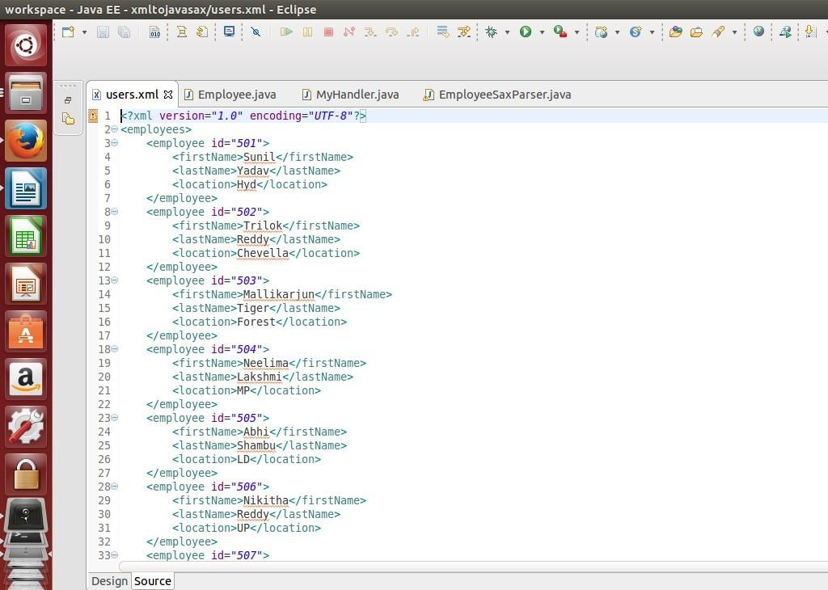

**userdetails:**

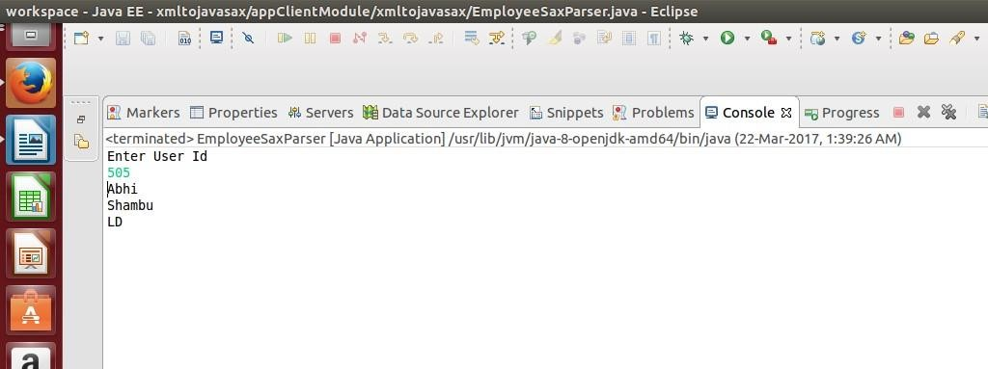

# EXPERIMENT – 7

**Implement the following web application using (a) PHP, (b) servlets and (c) JSP. PROBLEM STATEMENT:**

# USING PHP

A user validation web application, where the user submits the login name and password to the server. The name and password are checked against the data already available in database and if the data matches a successful login page is returned otherwise a failure message is shown to the user.

# SOURCE CODE:

<html>

<head>

<title>Login Now</title>

<script language="javascript">

function validate()

{

if(document.login.uname.value=="")

{

alert("enter username"); document.login.uname.focus(); return false;

}

if(document.login.pwd.value=="")

{

alert("enter password"); document.login.pwd.focus(); return false;

}

else{

return true;

}

}

</script>

</head>

<body>

<h3>Login</h3>

<form name="login" method="POST" action="" onsubmit="validate()">

<table>

<tr> <td>username</td>

<td><input type="text" name="uname"></td>

</tr>

<tr> <td>Password:</td>

<td><input type="password" name="pwd"></td>

</tr>

<tr> <td></td>

<td><input type="submit" name="login" value="Login"></td>

</tr> </table> </form>

<?php mysql_connect("localhost","kgruser","acd"); mysql_select_db("kgrdb"); if(isset($_POST['login']))

{

$user=($_POST['uname']);

$pass=($_POST['pwd']);

$res=mysql_query("select *from users where userid='$user' and pwd='$pass'");

if(mysql_num_rows($res))

{

} ?>

}

else

{

}

echo "<script> location.href='loginsuccess.php';</script>";

echo "Wrong Credentials";

</body>

</html>

## loginsuccess.php

<?php echo "Login successfully"; ?>

# OUTPUT:

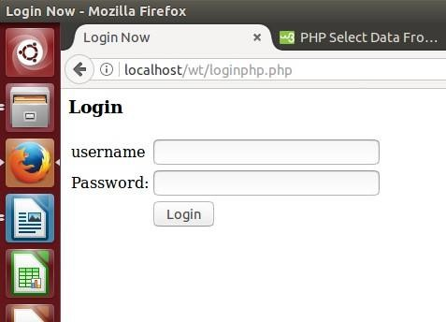

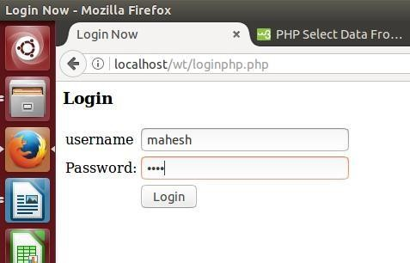

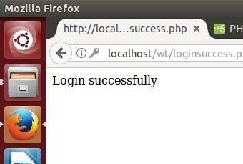

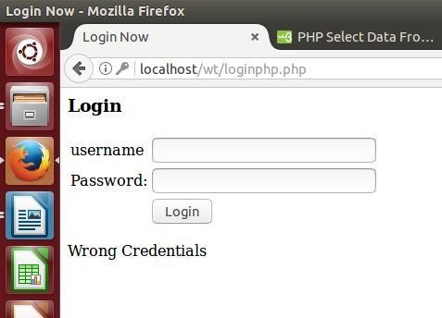

**EXPERIMENT – 8**

**PROBLEM STATEMENT:** Modify above program to use an xml file instead of database.

# PROGRAM:

## Step1: XML File creation userlist.xml

<?xml version="1.0" ?>

<userlist>

<user>

<username>mahesh</username>

<password>mahi</password>

</user>

<user>

<username>sunder</username>

<password>sun</password>

</user>

<user>

<username>abhijith</username>

<password>abhi</password>

</user>

</userlist>

## Source Code:

**xmllogin.php**

<html>

<head>

<title>Login Now</title>

<script language="javascript"> function validate()

{

if(document.login.uname.value=="")

{

alert("enter username"); document.login.uname.focus(); return false;

}

if(document.login.pwd.value=="")

{

alert("enter password"); document.login.pwd.focus(); return false;

}

else { return true;

}

}

</script>

</head>

<body>

<h3>Login</h3>

<?php

if(isset($_POST['login']))

{

$user=($_POST['uname']);

$pass=($_POST['pwd']);

$userdata = simplexml_load_file('userlist.xml') or die("Error: Cannot create object");

$found = 0;

foreach ($userdata as $key => $value) {

if($value->username == $user && $value->password == $pass)

{

$found = 1;

break;

}

}

if($found == 0)

{

}

else

{

}

} ?>

echo 'Invalid Username And Password Please Try Again';

echo "<script> location.href='loginsuccess.php';</script>";

<form name="login" method="POST" action="" onsubmit="validate()">

<table>

<tr> <td>username</td>

<td><input type="text" name="uname"></td>

</tr>

<tr>

</tr>

<td>Password:</td>

<td><input type="password" name="pwd"></td>

<tr> <td></td>

<td><input type="submit" name="login" value="Login"></td>

</tr>

</table>

</form>

</body>

</html>

## loginsuccess.php

<?php echo "Login successfully"; ?>

# OUTPUT:









**EXPERIMENT – 9**

**PROBLEM STATEMENT:** Modify the above program to use AJAX to show the result on the same page below submit button.

# SOURCE CODE:

## ajaxlogin.php

<html>

<head>

<title>Login Now</title>

<script language="javascript"> function validate()

{

var user=document.login.uname.value; var pwd=document.login.pwd.value; var obj;

if(window.XMLHttpRequest)

{

}

else

{

}

obj=new XMLHttpRequest();

obj=new ActiveXObject('Microsoft.XMLHTTP');

obj.open("POST","check.php?u="+user+"&p="+pwd,true); obj.send();

obj.onreadystatechange=function()

{

if(obj.readyState==4 && obj.status==200)

{

document.getElementById("success").innerHTML=obj.responseText;

}

}

}

</script>

</head>

<body>

<h3>Login</h3>

<form name="login" method="POST" action="check.php" onclick="validate()">

<table>

<tr> <td>username</td>

<td><input type="text" name="uname"></td>

</tr>

<tr> <td>Password:</td>

<td><input type="password" name="pwd"></td>

</tr>

<tr> <td></td>

<td><input type="button" value="submit"></td>

</tr>

</table>

</form>

<div id="success"></div>

</body>

</html>

## check.php

<?php

$user=$_REQUEST["u"];

$pass=$_REQUEST["p"]; mysql_connect("localhost","kgruser","acd"); mysql_select_db("kgrdb");

$res=mysql_query(" select * from users where userid='$user' and pwd='$pass' "); if(mysql_num_rows($res))

{ echo "you have sucessfully logged in"; }

else

?>

{ echo "wrong credentials"; }

# OUTPUT:

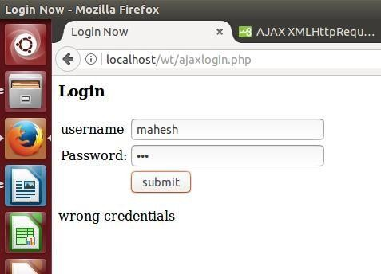

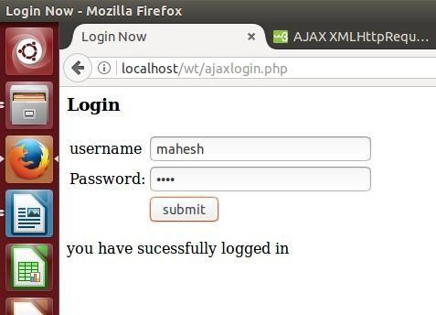

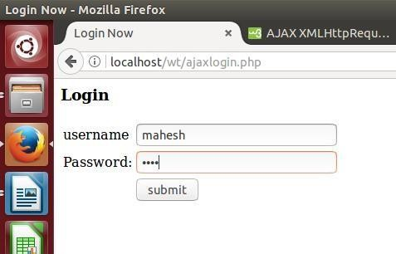

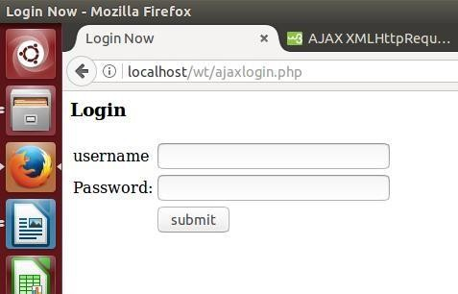

**EXPERIMENT – 10**

**PROBLEM STATEMENT:** A sample calculator web application that takes two numbers and an operator(+,-,*,/,%) from an HTML page and returns the result page with the operation performed on the operands.

# SOURCE CODE:

## calc.php

<html>

<head>

<title>calculator</title>

<script language="javascript"> function validateForm()

{

first=document.f1.fvalue.value; second=document.f1.lvalue.value; if(first=="")

{

alert("enter value"); document.f1.fvalue.focus(); return false;

}

if(isNaN(first))

{

alert("must enter number"); document.f1.fvalue.focus(); return false;

}

if(document.f1.operator.value=="")

{

alert("choose operator"); document.f1.operator.focus(); return false;

}

if(second=="")

{

alert("enter value"); document.f1.lvalue.focus(); return false;

}

if(isNaN(second))

{

alert("must enter number"); document.f1.lvalue.focus(); return false;

}

return true;

}

</script>

</head>

<body>

<form name="f1" method="post" action="success.php" onsubmit="return validateForm();">

<table cellpadding="5" cellspacing="5" border="0">

<tr>

<td>Enter First Number</td>

<td colspan="1"><input name="fvalue" id="fvalue" type="text"/></td>

<tr>

<td>Select Operator</td>

<td><select name="operator">

<option selected value=""> choose operator</option>

<option value="+">+</option>

<option value="-">-</option>

<option value="*">*</option>

<option value="/">/</option>

<option value="%">%</option>

</select></td>

</tr>

<tr>

<td>Enter second Number</td>

<td><input name="lvalue" type="text" id="lvalue"/></td>

</tr>

<tr>

<td></td>

<td><input type="submit" name="calculate" value="Calculate" /></td>

</tr>

</table>

</form>

</body>

</html>

## success.php

<?php

if( isset( $_REQUEST['calculate']))

{

$operator = $_REQUEST['operator']; if($operator == "+")

{

$add1 = $_REQUEST['fvalue'];

$add2 = $_REQUEST['lvalue'];

$res = $add1 + $add2;

$result = 'SUM';

}

if($operator == "-")

{

$add1 = $_REQUEST['fvalue'];

$add2 = $_REQUEST['lvalue'];

$res = $add1 - $add2;

$result = 'DIFFERENCE';

}

if($operator == "*")

{

$add1 = $_REQUEST['fvalue'];

$add2 = $_REQUEST['lvalue'];

$res = $add1 * $add2;

$result = 'PRODUCT';

}

if($operator == "/")

{

$add1 = $_REQUEST['fvalue'];

$add2 = $_REQUEST['lvalue'];

$res= $add1 / $add2;

$result = 'DIVISION';

}

if($operator == "%")

{

$add1 = $_REQUEST['fvalue'];

$add2 = $_REQUEST['lvalue'];

$res= $add1 % $add2;

$result = 'REMAINDER';

}

}

?>

<?php echo "The <strong>".$result."</strong> Of <strong>".$add1."</strong> And

<strong>".$add2."</strong> Is <strong>". $res."</strong>"; ?>

<br/><br/><a href="calc.php">click Here</a> To Go Back To Calculator

# OUTPUT:

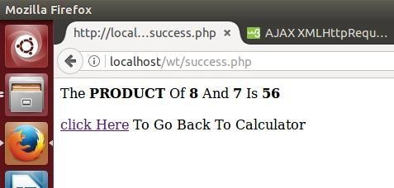

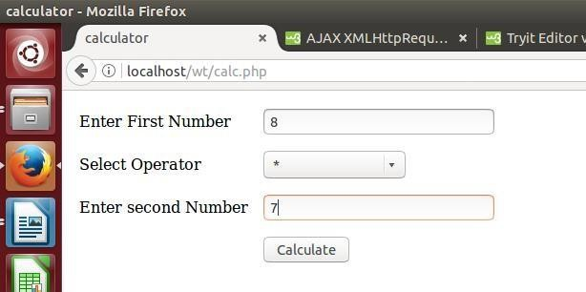

**EXPERIMENT – 11**

**PROBLEM STATEMENT:** A calculator web application which stores each query in a database and checks in the database first for the result. If the query exists in DB it returns the value which was computed previously otherwise it computes the result and returns after storing the query and result in DB

## PROGRAM: A calculator web application which stores the query and result in DB. calc.php

<html>

<head>

<title>calculator</title>

<script language="javascript"> function validateForm()

{

first=document.f1.fvalue.value; second=document.f1.lvalue.value; if(first=="")

{

alert("enter value"); document.f1.fvalue.focus(); return false;

}

if(isNaN(first))

{

alert("must enter number"); document.f1.fvalue.focus(); return false;

}

if(document.f1.operator.value=="")

{ alert("choose operator"); document.f1.operator.focus(); return false;

}

if(second=="")

{

alert("enter value"); document.f1.lvalue.focus(); return false;

}

if(isNaN(second))

{

alert("must enter number"); document.f1.lvalue.focus(); return false;

}

return true;

}

</script>

</head>

<body>

<form name="f1" method="post" action="success.php" onsubmit="return validateForm();">

<table cellpadding="5" cellspacing="5" border="0">

<tr>

<td>Enter First Number</td>

<td colspan="1"><input name="fvalue" id="fvalue" type="text"/></td>

<tr>

<td>Select Operator</td>

<td><select name="operator">

<option selected value=""> choose operator</option>

<option value="+">+</option>

<option value="-">-</option>

<option value="*">*</option>

<option value="/">/</option>

<option value="%">%</option>

</select></td>

</tr>

<tr>

<td>Enter second Number</td>

<td><input name="lvalue" type="text" id="lvalue"/></td>

</tr>

<tr>

<td></td>

<td><input type="submit" name="calculate" value="Calculate" /></td>

</tr>

</table>

</form>

</body>

</html>

## Success.php

<?php

if( isset( $_REQUEST['calculate']))

{

$operator = $_REQUEST['operator']; if($operator == "+")

{

$add1 = $_REQUEST['fvalue'];

$add2 = $_REQUEST['lvalue'];

$res = $add1 + $add2;

$result = 'SUM';

}

if($operator == "-")

{

$add1 = $_REQUEST['fvalue'];

$add2 = $_REQUEST['lvalue'];

$res = $add1 - $add2;

$result = 'DIFFERENCE';

}

if($operator == "*")

{

$add1 = $_REQUEST['fvalue'];

$add2 = $_REQUEST['lvalue'];

$res = $add1 * $add2;

$result = 'PRODUCT';

}

if($operator == "/")

{

$add1 = $_REQUEST['fvalue'];

$add2 = $_REQUEST['lvalue'];

$res= $add1 / $add2;

$result = 'DIVISION';

}

if($operator == "%")

{

$add1 = $_REQUEST['fvalue'];

$add2 = $_REQUEST['lvalue'];

$res= $add1 % $add2;

$result = 'REMAINDER';

}

mysql_connect("localhost","kgruser","acd"); mysql_select_db("kgrdb");

$rst=mysql_query("select fval,opr,lval from calculator");?>

<div>

<?php if (!$rst) { echo 'Could not run query: ' . mysql_error();

exit;

}

$rows=mysql_num_rows($rst);

//echo $rows;

$flag=0; if($rows==0)

{

mysql_query("INSERT INTO calculator values($add1,'$operator',$add2,$res)");

echo "The <strong>".$result."</strong> Of <strong>".$add1."</strong> And <strong>".$add2."</strong> Is <strong>". $res."</strong>";

}

else while($row=mysql_fetch_array($rst))

{

if($row[0]===$add1 && $row[1]===$operator && $row[2]===$add2)

{

$dresult=mysql_query("select result from calculator where fval=$add1 and opr='$operator' and lval=$add2");

$drval=mysql_fetch_row($dresult);

echo "The <strong>".$result."</strong> Of <strong>".$add1."</strong> And

<strong>".$add2."</strong> Is <strong>".

$drval[0]."</strong>";?><br/><br/><a href="calc.php">click Here</a> To Go Back To Calculator

<?php exit();

}

else

{

$flag=1;

}

}

if($flag==1)

{

mysql_query("INSERT INTO calculator values($add1,'$operator',$add2,$res)");

echo "The <strong>".$result."</strong> Of <strong>".$add1."</strong> And

<strong>".$add2."</strong> Is <strong>". $res."</strong>";

}

}?><div>

<br/><br/><a href="calc.php">click Here</a> To Go Back To Calculator

**OUTPUT:**

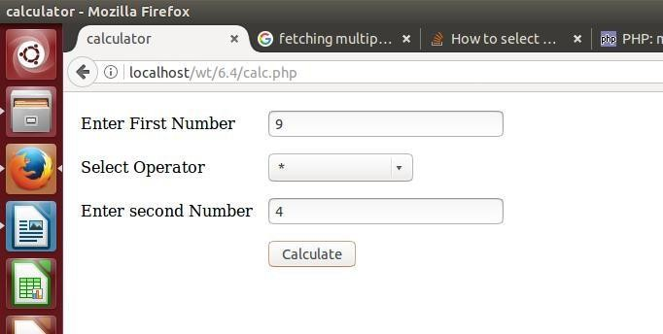

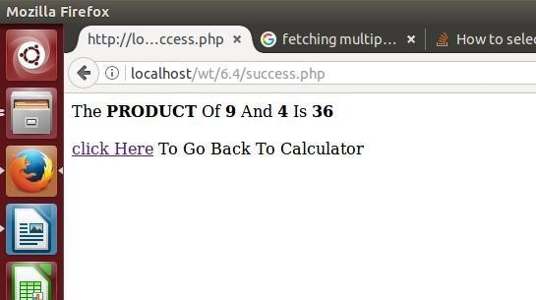

**EXPERIMENT – 12**

**PROGRAM STATEMENT:**

**A web application which takes name as input and displays a page with Hello <name>, logout button and start time on right corner and display another page with thank <name> and duration of usage. (hint: Use session to store name and time).**

**PROGRAM: web application displaying the user given name along with session duration. SOURCE CODE:**

**Sessionnt.php**

<html>

<head>

<title> session time </title>

</head>

<body>

<form action="logout.php" method="POST">

Enter name<input type="text" name="name" value=""/>

<input type="submit" name="submit" value="submit"/>

</form>

</body>

</html>

## Logout.php

<?php session_start();

$_SESSION['name']=$_POST['name']; if (!isset($_SESSION['start_time']))

{

$str_time = time();

$_SESSION['start_time'] = $str_time;

}?>

<html>

<body>

<div>

<span style="float:right">

<?php

echo date("H:i:s",$_SESSION['start_time']);?></span>

</div>

<?php echo "Hello ".$_POST['name'];?><br>

<form action="logoutsession.php" method="POST">

<input type="submit" name="submit" value="Logout">

</body>

</html>

## logoutsession.php

<?php session_start();

$duration=time()-$_SESSION['start_time'];?>

<html>

<head> <title> Session Logout </title></head>

<body>

<?php echo "Thank You ".$_SESSION['name']."<br>". "Duration of the Session "."<br>".date("H:i:s",$duration);?>

</body>

</html>

**OUTPUT:**

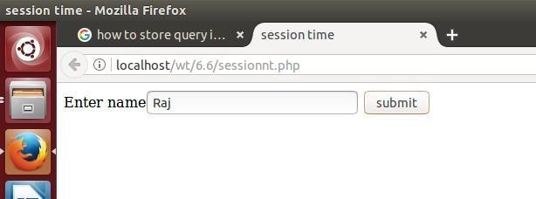

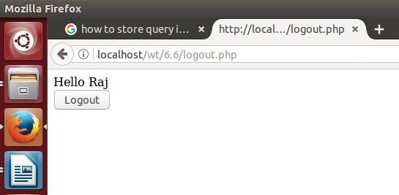

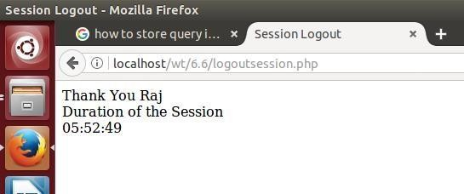

**EXPERIMENT – 13**

# PROBLEM STATEMENT:

**A web application that takes name and age from an HTML page. If the age is less than 18, it should send a page with “Hello <name>, you are not authorized to visit this site” message, where**

**<name> should be replaced with the entered name. Otherwise it should send “Welcome <name> to this site” message.**

**AIM: To display appropriate page based on user age. PROGRAM:**

**userform.php**

<html>

<head>

<title> Authorization of user</title>

<body>

<form action="authenticate.php" method="POST"> Name <input type="text" name="name" value=""/> Age <input type="text" name="age" value=""/>

<input type="submit" value="submit"/>

</form>

</body>

</html>

## authenitcate.php

<?php if($_POST['age']<18)

{

echo "Hello ".$_POST['name']." You are not authorized to visit this site";

}

else {

echo "Welcome ".$_POST['name']." to this site";

}

?>

# OUTPUT:

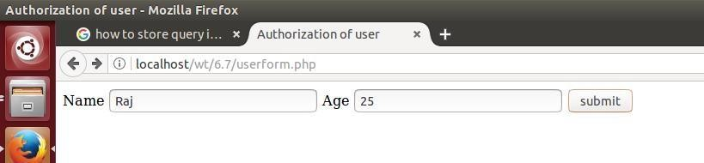

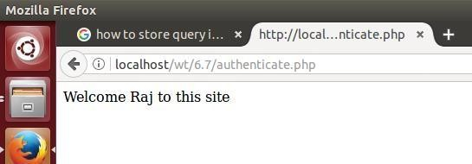

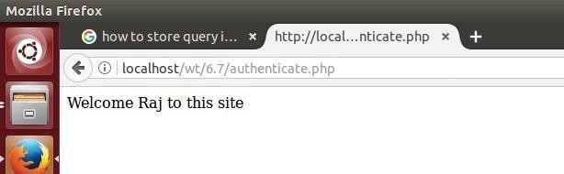

**EXPERIMENT – 14**

## PROBLEM STATEMENT: A web Application for Implementation:

**Take user name and password and check against the database if username and password matches, display a welcome page with user's full name if name matches and password doesn't match then display “password mismatch” page. If name not found in the data base take full name from user and store username, password and full name in the data base using registration page. (Use sessions to store username and password.)**

**AIM:** Developing a web application to check login credentials of user and displaying welcome page upon success other register the user with full name.

# PROGRAM:

## loginphp.php

<html>

<head>

<title>Login Now</title>

<script language="javascript">

function validate()

{

|  |
| --- |
| if(document.login.uname.value=="") |
| { |
| alert("enter username"); |
| document.login.uname.focus(); |
| return false; |
| } |
| if(document.login.pwd.value=="") |
| { |
| alert("enter password"); |
| document.login.pwd.focus(); |
| return false; |
| } |
| else{ |
| return true; |
| } |

}

</script>

</head>

<body>

<h3>Login</h3>

<form name="login" method="POST" action="" onsubmit="validate()">

<table>

<tr>

</tr>

<tr>

<td>username</td>

<td><input type="text" name="uname"></td>

<td>Password:</td>

<td><input type="password" name="pwd"></td>

</tr>

<tr>

<td></td>

<td><input type="submit" name="login" value="Login"></td>

</tr>

</table>

</form>

<?php

session_start(); mysql_connect("localhost","kgruser","acd"); mysql_select_db("kgrdb");

if(isset($_POST['login']))

{

$user=($_POST['uname']);

$pass=($_POST['pwd']);

$res=mysql_query("select userid,pwd from users where userid='$user'");

$row=mysql_fetch_row($res);

if($row[0]==$user)

{

if($row[1]==$pass)

{

$res=mysql_query("select name from users where userid='$user' and

pwd='$pass'");

$fname=mysql_result($res,0);

$_SESSION['fname']=$fname;

echo "<script> location.href='welcome.php';</script>";

}

else

{

echo "<script> location.href='pwdmismatch.php';</script>";

}

}

else

{

$_SESSION['user']=$user;

$_SESSION['pwd']=$pass;

echo "<script> location.href='reguser.php';</script>";

}

}?>

</body>

</html>

## welcome.php

<?php session_start();

echo "Welcome ".$_SESSION['fname'];

?>

## passwordmismatch.php

<?php session_start();

echo "Password is incorrect";

?>

## reguser.php

<html>

<head>

<title> Registration form </title>

<body>

<form name="reg" action="" method="POST">

<h3> User Registration </h3>

Enter Full Name<input type="text" name="fname" value=""/>

<input type="submit" name="submit" value="submit"/>

</form>

<?php

session_start();

$uid=$_SESSION['user'];

$pwd=$_SESSION['pwd']; mysql_connect("localhost","kgruser","acd"); mysql_select_db("kgrdb"); if(isset($_POST['fname'])){

$fname=$_POST['fname'];

$res=mysql_query("INSERT INTO users values('$uid','$pwd','$fname')"); if($res===TRUE)

{

echo "Registration Completed Successfully";

}

}?>

</body>

</html>

# OUTPUT:

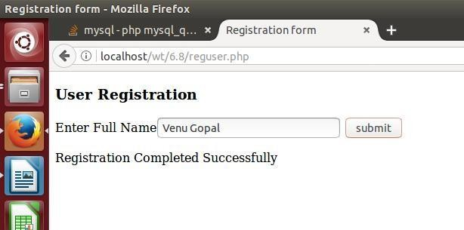

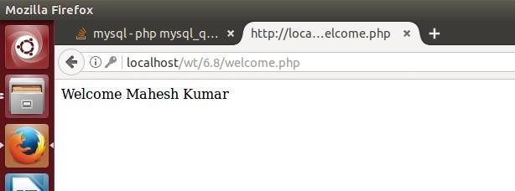

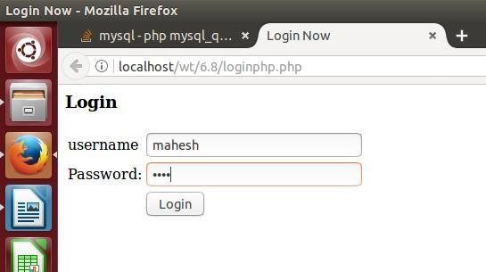

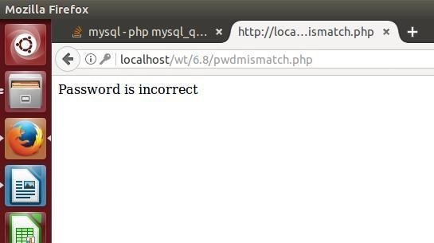

**EXPERIMENT – 15**

## PROBLEM STATEMENT: A web application that lists all cookies stored in the browser on clicking “List Cookies” button.

**AIM:** A web application to list all cookies stored in the browser.

# PROGRAM:

## Listcookies.php

<html>

<head>

<title> Choose List Cookies </title>

</head>

<body>

<form action="displaycookies.php" method="POST"/>

<input type="submit" name="submit" value="List Cookies"/>

</form>

<?php setcookie("name","Sunder"); setCookie("age","18"); setCookie("address","Hyderabad");

?>

</body>

</html>

## displaycookies.php

<?php

$cookie=$_COOKIE;

foreach ($cookie as $key=>$val) echo "<br>$key : $val";

?>

**OUTPUT:**

